**Database Design-Package Diagram**

**Version 1.1**

**Project Management App**

**Team A**

**CSC-355**

**Spring 2016**



02/19/2016

Author: Tyler Mariano – System Designer & Jennifer Li – Project Leader

Submitted To: Dr. Joo Tan

**TABLE OF CONTENTS**

Revision History…………………………………………………………………………………..ii

1.0 Introduction……..….....…………………………….…...…………………………….……....1

2.0 Database System………………………………………………………………………………1

2.1 Overview………………………………………………………………………………..

2.2 Type of Database……………………………………………………………………….

2.3 Tables and Attributes…………………………………………………………………...

2.4 ER Diagram…………………………………………………………………………….

2.5 Table Details…………………………………………………………………………....

2.5.1 UserTable…………………………………………………………………….

2.5.2 ProjrctTable…………………………………………………………………..

2.5.3 TaskTable…………………………………………………………………….

2.5.4 ProgressTable………………………………………………………………...

**REVISION HISTORY**

|  |  |  |  |
| --- | --- | --- | --- |
| Version | Author | Description | Date |
| 1.0 | Jennifer Li | I created the first draft. | 1/31/2016 |
|  | Jennifer Li | Created tables outlines | 02/15/2016 |
|  | Jennifer Li | Added Section 1 and 2.2 | 02/16/2016 |
| 1.1 | Tyler Mariano | I added descriptions to each table and completed the overview. Also, added attribute descriptions and examples. | 02/17/2016 |

**1.0 INTRODUCTION**

The purpose of this document is to explain the design of the Project Management App database, show the relationships between each of the database entities, and illustrate how they interact with the application. This document also illustrates details regarding the software and technologies that will be implemented.

**2.0 Database System**

A database can be defined/described in many ways. Below you will find a basic overview of what database software, tables, and relationships we are using to create the Project Management database. There is an ER-Diagram to visually show table relationships and table descriptions to help explain their functionality and purposes. Lastly, each of the database table’s attributes have explanations and examples.

**2.1 Overview**

The Project Management database will be implemented using SQLite. The database will be created using the sqlitebrowser software. We will also be using this software for storage and maintenance of the database. Using this software will allow for easier database manipulation in the future and smooth transitions if we would ever like to change our database to a higher level software due sqlitebrowser’s export functionality. The database currently only has 4 tables: UserTable, ProjectTable, TaskTable, and ProgressTable. These 4 tables hold all the key data that the app will use on a daily basis. Since this database is easily manipulated we will continually look for ways to improve its speed and lessen its storage complexity, then make updates accordingly.

**2.2 Type of Database**

The type of database used in the Project Management App is a relational database powered by SQLite. It has a total of 4 tables (for now), each table is important for application use. The tables are as follows: UserTable, ProjectTable, TaskTable, ProgressTable.

**2.3 Tables and Attributes**

Below is a chart showing each table and its attribute.

|  |  |
| --- | --- |
| Table | Attributes |
| UserTable | UserID (primary key), FirstName, LastName, Email, Password, Bio, ProjectList, Picture |
| ProjectTable | ProjectID (primary key), Leader, MemberList, Name, Description, Progress |
| TaskTable | TaskID (primary key), UserID, ProjectID, Description, Progress, Status, Priority, DueDate, Dependency |
| ProgressTable | ProgressID (primary key), UserID, ProjectID, TaskID, Progress |

**2.4 Relationships**

Below is an ER Diagram showing each table and its relationship to other tables.

(This diagram was made using Adobe Fireworks CS6)

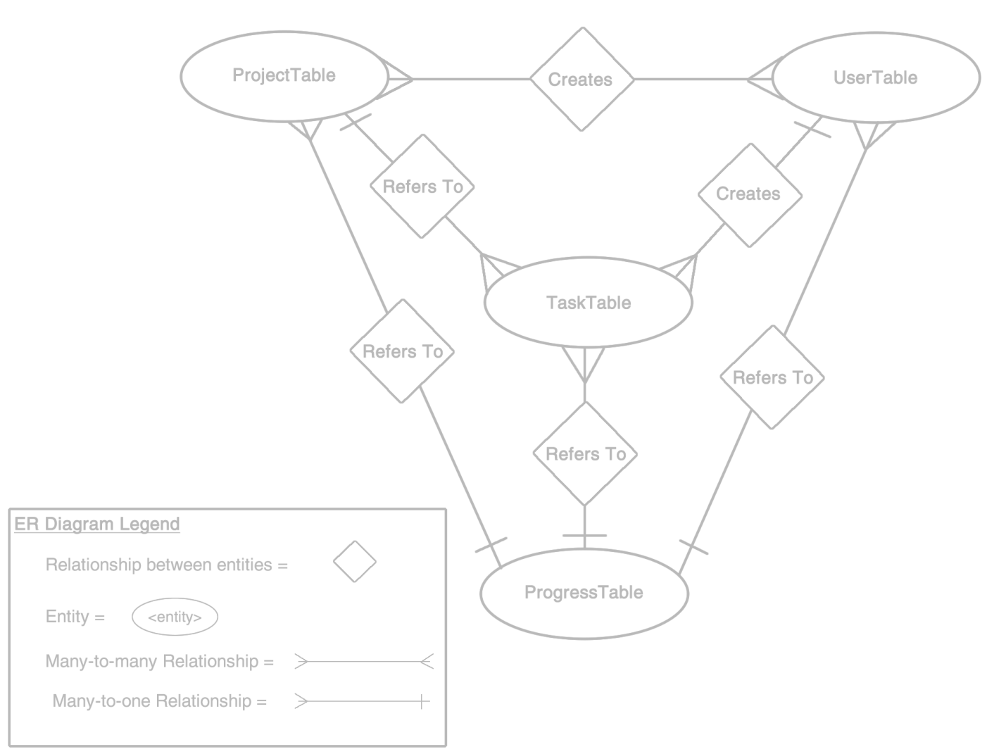

**2.5 Table Details**

This section contains a brief description of each table and a chart, documenting its attributes, attribute types, and attribute descriptions. Please note that this relational database is using SQLite. Therefore, it is very light weight and does not come with all the usual bells and whistles of MySQL. For example, the data type VARCHAR(255) falls within SQLite’s TEXT affinity, this is why you won’t see the data type size in the tables to follow. For more information on this topic please consult <https://www.sqlite.org/datatype3.html>.

**2.5.1 UserTable**

The UserTable below is used to hold the basic information of a system user. The UserID acts as the primary key and is automatically generated and incremented each time a new user is created. The only required fields for creating an account are Email and Password to allow the user to quickly access the application. Users will be able to update the fields: FirstName, LastName, Bio, and Picture from the profile screen within the app. Lastly, the ProjectList column will hold a comma separated string of ProjectIDs. This section is multi-valued to allow for easy access to all projects a specific user is a part of.

|  |  |  |
| --- | --- | --- |
| Attributes | Data Type | Description & Example |
| UserID | INTEGER | This column is the primary key and is the unique auto incremented row identifier. Example: 1 |
| FirstName | TEXT | This column holds a string variable of the user’s first name. Example: Tyler |
| LastName | TEXT | This column holds a string variable of the user’s last name. Example: Mariano |
| Email | TEXT | This column is a required field that must also be unique so users cannot have the same email. Example: tmari795@live.kutztown.edu |
| Password | TEXT | This column is a required field to hold the password for which the storage specification are to be determined. Example: Mariano2365 |
| Bio | TEXT | This column holds a string which contain a user’s skills, title, experience, etc. Example: System Designer for 3 years |
| ProjectList | TEXT | This column holds a comma separated list of ProjectIDs from the ProjectTable. Example: 1,2,3,4,5,6… |
| Picture | BLOB | This column used to hold image URL. Example: http://104.238.131.94:5000/img.jpg |

**2.5.2 ProjectTable**

The ProjectTable below is used to hold all the information of a project. The ProjectID acts as the primary key and is automatically generated and incremented each time a new project is created. The required fields for creating a project are Leader, ProjectName and ProjectDescription which can all be found on the create account screen. The Leader field will automatically be filled in with the UserID of the project creator and acts as a foreign key. The leader will be able to update the fields: MemberList and TaskList from the leader view screen within the app. Lastly, the MemberList and TaskList columns will hold a comma separated string of UserIDs and TaskIDs. These sections are multi-valued to allow for easy access, for the leader, to all project members and all project tasks contained within a specific project.

|  |  |  |
| --- | --- | --- |
| Attributes | Data Type | Description & Example |
| ProjectID | INTEGER | This column is the primary key and is the unique auto incremented row identifier. Example: 1 |
| Leader | TEXT | This column is required and is a foreign key relating to the project creator’s UserID from the UserTable. Example: 1 |
| MemberList | TEXT | This column holds a comma separated list of UserIDs from the UserTable. Example: 1,2,3,4,5,6… |
| TaskList | TEXT | This column holds a comma separated list of TaskIDs from the TaskTable. Example: 1,2,3,4,5,6… |
| ProjectName | TEXT | This column is a required field that holds a string variable of the project’s name. Example: Flappy Bird |
| ProjectDescription | TEXT | This column is a required field that holds a string variable of the project’s description. Example: Create a mobile game |

**2.5.3 TaskTable**

The TaskTable below is used to hold all the information of a task. The TaskID acts as the primary key and is automatically generated and incremented each time a new task is created. The User and Project fields will be foreign keys to allow the task to relate to the ProjectTable and the UserTable so the task knows which project the task belongs to and who is assigned to complete it. The required fields for creating a task are User, Project, TaskName, TaskDescription, TaskPriority, and TaskDueDate which can all be found on the create task screen via the leader screen. The leader will be able to update the fields: TaskStatus and TaskProgress from the leader view screen within the app after a task has been submitted.

|  |  |  |
| --- | --- | --- |
| Attributes | Data Type | Description & Example |
| TaskID | INTEGER | This column is the primary key and is the unique auto incremented row identifier. Example: 0 |
| User | INTEGER | This column is required and is a foreign key relating to the UserID from the UserTable. Example: 1 |
| Project | INTEGER | This column is required and is a foreign key relating to the ProjectID from the ProjectTable. Example: 1 |
| TaskName | TEXT | This column is a required field that holds a string variable of the task’s name. Example: Design User Interface |
| TaskDescription | TEXT | This column is a required field that holds a string variable of the task’s description. Example: Design a visually appealing interface for the Flappy Bird project |
| TaskProgress | REAL | This column is a field that holds a real value of the task’s progress based on positively reviewed task submissions. Example: 33.3% |
| TaskStatus | TEXT | This column is a field that holds a string variable of the task’s status once it has been submitted. Example: Accepted, partially accepted, or failed |
| TaskPriority | INTEGER | This column is a required field that holds an integer value of the task’s priority. Example: Range from 1-5 |
| TaskDueDate | TEXT | This column is a required field that holds a string variable of the task’s due date in year-month-day format. Example: 2016-02-21 |

**2.5.3 ProgressTable**

The ProgressTable below is used to hold the task progress of all of a user’s tasks within a specific project. For example, an individual task has it’s own progress. Whereas, a project has progress based on all tasks that are a part of it which could be assigned to multiple project members. Therefore, the ProgressTable holds all the tasks that just one member is a assigned to within a specific project. The ProgressID acts as the primary key and is automatically generated and incremented each time a new task is assigned to a new project member. The User, Project, and Task fields will be foreign keys to allow the progress to relate to the UserTable, ProjectTable, and TaskTable so the progress can differenciate between which tasks a user has for only a specific project. Lastly, the AllTaskProgress field holds the sum of all of a user’s task progress within a specific project.

|  |  |  |
| --- | --- | --- |
| Attributes | Data Type | Description & Example |
| ProgressID | INTEGER | This column is the primary key and is the unique auto incremented row identifier. Example: 0 |
| User | INTEGER | This column is required and is a foreign key relating to the UserID from the UserTable. Example: 1 |
| Project | INTEGER | This column is required and is a foreign key relating to the ProjectID from the ProjectTable. Example: 1 |
| Task | INTEGER | This column is required and is a foreign key relating to the TaskID from the TaskTable. Example: 1 |
| AllTaskProgress | REAL | This column is a field that holds a real value of a user’s total task progress in a specific project. Example: 33.3% |